COMMUNITY COLLEGE OF PHILADELPHIA
Course Development Template
- Course Designation | ENGL
- Course Title | English Corequisite Seminar Program
- Abbreviated Course Title for Banner | ENGL 097 Coreq Seminar Program
- Division | Liberal Studies
- Department | English
- Course Description | The Corequisite Seminar Program provides supplementary instruction for students also enrolled in a linked, college-level course. All assignments in English 097 will provide practice in the development of academic reading, writing, and study skills to enable concurrent success in the college-level course.
- Prerequisites/Corequisites | Mandatory corequisite: a credit-bearing course taught by the same instructor. Students must remain in both courses to continue in the Corequisite Seminar Program.
- Placement | English 097  No math placement level
- Hours and Credits | 3-0-3
- Class size (maximum) | 13
- Programs where this course appears | None
- Faculty Developer(s) | Myla Morris-Skeiker  Brian Goedde
- Facilitator (s) | Cynthia Giddle
- Recommended Starting Semester | Fall 2022
- Course Revision or New Course? | Course Revision
- If this is a course revision, indicate which are being revised | ☒Prerequisite(s) and/or placement | ☒Course Title or Number |  | ☒Course Description
 | ☐Credit/Lab/External Hours |  | ☒CLOs and/or Methods of Assessment
- Course Attributes | None
- Today’s Date | February 17, 2022

A. Rationale

The ENGL 097 course revision is being proposed in order to meet three significant needs for the CCP student population: learning and practicing academic reading and writing skills in the context of an academic subject; providing developmental students the opportunity to earn college credit in their first semester; providing developmental students the opportunity to begin completing college-level courses.

Both Community College of Philadelphia and community colleges nationwide have found tremendous success in using the co-requisite model for accelerating ENGL 101 course completion for developmental students. The Corequisite Seminar Program (CSP) seeks to advance the lessons learned from the Accelerated Learning Program and provide an equally beneficial, contextual learning experience for students who place below the college level and whose placement indicates the need for more than one semester of developmental coursework.

The decision to revise the ENGL 097 course rather than develop an entirely new course was made in the best interest of students. In a previous course sequence, ENGL 097 was a pre-requisite to ENGL 098. Though it was not offered in the preceding decade, the course has remained active. ENGL 097 is an integrated reading and writing course that will replace the current ENGL 098/ENGL 099 link and be linked to a content course.

Given the context presented above, this course revision differs from the current course in several significant ways: 1. the course title, 2. the corequisite requirement, 3. the course description, and 4. the Course Learning Outcomes (CLOs).
- The course title is currently “Basic Writing Skills.” The proposed course title is “English Corequisite Seminar Program.”
- The course currently does not have a corequisite. The proposed course does: English 097 students also enroll in a college-level, credit-bearing course such as ENGL 116 Interpersonal Communication, BLAS 101 Introduction to Black Studies, or HUM 101 Cultural Traditions (Ancient to the 13th Century). The proposed purpose of English 097 is to provide supplementary instruction to enable success for students enrolled in the corequisite college-level course.
- The proposed course description differs significantly in purpose and tone. While it would remain a “developmental” class, devoted to building rudimentary skills necessary for success in college, the proposed iteration of English 097 is a corequisite to college level work, where the previous was a prerequisite to college level work.
The difference of prefix is monumental. The previous course description stated that this was a course for “students with serious problems”; in describing “student characteristics,” it emphasizes “deficiencies.” The revised course description acknowledges the need for building rudimentary reading, writing, and study skills, but the approach to skill development that it describes positions the instructor and student to have an asset-based, not deficit-based, partnership. A developmental prerequisite keeps students out of college credit-bearing opportunities because of perceived “problems” and “deficiencies.” A developmental corequisite, by contrast, allows students to enroll in credit-bearing coursework, then concurrently provides adequate supplementary instruction to build the skills needed to be successful in the college-level class.

Current Course Description:

For students with serious problems, little experience in writing.
Organization and clarity in thinking and expression, vocabulary
development and appropriate uses of language, and the
construction of sentences and simple expository paragraphs.
Problems of spelling, capitalization and punctuation.

Proposed Course Description:

The Corequisite Seminar Program provides supplementary instruction
for students also enrolled in a linked, college-level general education
course. All assignments in English 097 will provide practice in the
development of academic reading, writing, and study skills to enable
concurrent success in the college-level course.

- Finally, while there is also some continuity between the current CLOs and the proposed outcomes below (see Section B), the outcomes below are consistent with the current, college-wide, CLO format.

Michelle Myers, Jason Esters, Junior Brainard, and Mary Hoeffel contributed significantly to the revision of the course.

B. Course Learning Outcomes and Methods of Assessment

Current Course Learning Outcomes:

Goals:
The student will:
- describe relationships and differences between speech, reading and writing.
(CLO I)

- improve diction and language usage in writing.
(CLO II)

- organize ideas logically and clearly.
(CLO III)

- recognize, construct, assess and evaluate complete sentences.
(CLO IV)

- improve spelling.
(CLO V)

- recognize and construct paragraphs.
(CLO VI)

- learn to write words, sentences, and paragraphs, blending them into an essay or report.
(CLO I to VI)

Proposed Course Learning Outcomes:

Course Learning Outcome  Upon successful completion of the course, students will be able to: | Method of Assessment
1. Restate and apply instructions of corequisite content course assignments. | Quizzes, reflection journals, discussion board assignments
2. Practice process-based reading strategies such as “the 5 Ws,” “PQ3R,” vocabulary acquisition, and annotation to discuss genre, purpose, and efficacy of evidence in content course reading material. | Worksheets, annotations, discussion board assignments, quizzes
3. Produce short essays utilizing strategies such as brainstorming, drafting, revising, and proofreading for grammar and clarity of written expression. | Short essays; pre-writing activities including brainstorming and outlining; revision exercises such as peer-reviewing and proofreading activities
4. Apply test-taking, pre-writing, and pre-reading strategies to content course assignments, activities, and exams. | Quizzes, worksheets, annotations, study guides, reflection journals
5. Assess their own reading, writing, and study skill processes for areas of strength and growth. | Discussion board assignments, reflection journals

C. Grading

The grading schema below is not mandatory, but a suggestion, of how grades can be earned in English 097:

Quizzes | 20%
Discussion board assignments and reflection journals | 20%
Reading worksheets and annotations | 20%
Pre-writing, peer-review, and grammar exercises | 20%
Exam preparation worksheets | 10%
Attendance | 10%
Total | 100%

English 097 is graded using the marks Pass (P), Making Progress (MP), and Fail (F). Students do not receive traditional letter grades or transferable credit for this course.

Students who earn a grade of P enroll in English 101 in their following semester. Students who earn a grade of MP enroll in English 101 with the developmental support corequisite English 098, the Accelerated Learning Program (ALP). Students who earn a grade of F must repeat 097.

Note: Students who fail the corequisite class that 097 supports (eg. HUM 101) will be advised to re-take the same corequisite class to improve their G.P.A. However, they would also be able to choose a different course in the Corequisite Seminar Program.

D. Planned Sequence of Topics

Below is a planned sequence of topics for English 097. As this course directly and thoroughly supports a college-level, general education corequisite, it is necessary to include a column of the planned sequence of topics in such a class as well. This column is on the left in the table below; it is an example of how English 097 would support English 190 Introduction to Literature.

This is not a mandatory list of topics that all future instructors must cover, including instructors who will teach English 190 Introduction to Literature as part of the CSP. Instructors are free to modify the planned sequence of topics.

Week | ENGL 190 Introduction to Literature (Readings and major assignments only) | ENGL 097 Corequisite Seminar Program
1 | Syllabus, Introductions: how to read and write for a literature class | Syllabus Quiz  Reflection journal 1
2 | Flash Fiction International (FFI) part 1 | FFI part 1 Quiz  Reflection journal 2  Fiction annotation
3 | FFI part 2  Essay #1 Fiction | FFI part 2 Quiz  Discussion board assignment 1  Peer-review editing discussion board
4 | Selected poetry from the Poetry Foundation part 1 (www.poetryfoundation.org) | Poetry Foundation selection part 1 Quiz  Reflection journal 3  Poetry annotation
5 | Selected poetry from the Poetry Foundation part 2  Essay #2 Poetry | Poetry Foundation part 2 Quiz  Discussion board assignment 2  Peer-review proofreading worksheet
6 | Midterm Exam | Midterm Exam preparation worksheet  Midterm Exam reflection journal
7 | Selected plays from Take Ten: 10 Minute Plays part 1 | Take Ten part 1 Quiz  Reflection journal 4  Annotating plays
8 | Selected plays from Take Ten: 10 Minute Plays part 2  Essay #3 Playwriting | Take Ten part 2 Quiz  Peer-review outlining discussion board  Discussion board assignment 3
9 | The Fire This Time (TFTT) part 1 | TFTT part 1 Quiz  Reflection journal 5  Annotating literary essays
10 | The Fire This Time part 2  Essay #4 Literary Essay | TFTT part 2 Quiz  Discussion board assignment 4  Peer-review editing discussion board
Major work for extended study and Essay #5: | -Toni Morrison, The Bluest Eye | Outside class context viewing:  Toni Morrison: The Pieces I Am (2019)
11 | Major work part 1 | Major work part 1 Quiz  Major work Annotation
12 | Major work part 2 | Major work part 2 Quiz  Reflection journal 6
13 | Major work part 3 | Major work part 3 Quiz  Discussion board assignment 5
14 | Essay #5 Literature Paper | Peer-review editing discussion board  Peer-review proofreading worksheet
15 | Final Exam | Final Exam preparation worksheet  Final Exam reflection journal

E. Student Learning Activities and Assignments

English 097 students did not place at the college-level, but as part of the Corequisite Seminar Program, they enroll in a college-level class that English 097 supports. The purpose of the student learning activities and assignments in English 097 are therefore to provide necessary supplemental instruction, to build on the rudimentary skills of reading, writing, and studying, to enable the success in the college-level corequisite.

This supplemental instruction comes in three broad categories that encompass the Course Learning Outcomes above: 1) review and reinforcement of content course material and assignments, 2) “scaffolded” reading and writing instruction, and 3) meta-cognitive preparation for content course exams, projects, and other assignments.

The review and reinforcement of content course material is indicated in the first Course Learning Outcome, “Restate and apply instructions of corequisite content course assignments.” To be successful in the co-requisite content course, students in English 097 typically need an activity or exercise to grasp the course’s instruction, assignments, and expectations thoroughly and accurately. This activity can be an annotation assignment in which students take notes on a written assignment in the content course, or a paraphrasing of the assignment (see Appendix for Sample Assignments #1). Alternatively, students may take a quiz, or write a reflection journal on an online discussion board to restate the assignment’s requirements.

A common characteristic of English 097 students is that they are underprepared for college-level reading and writing. Both reading and writing assignments in the corequisite content course will likely present challenges to English 097 students, so supplemental instruction is necessary. For reading assignments, textual analysis in the form of “the 5 W’s” or PQ3R are effective, and annotation is essential (see Appendix for Sample Assignments #2 and #3). Student retention and comprehension can also, of course, be quizzed (see Sample Assignment #4). For writing, “scaffolding” of the drafting and revision process is essential for student success in the content course. Each step of the paper writing process can become a low-stakes assignment, such as formatting a paper, including the Works Cited page, that positions the student to be successful on the content course assignment. Organization and planning exercises are also useful (see Sample Assignment #5). Peer-review can make the feedback and revision process collaborative (see Sample Assignment #6), while keeping students on track to produce the artifacts that demonstrate they are reaching the content course outcomes.

Finally, English 097 students typically show a need to develop meta-cognitive skills of preparation and self-assessment. If there is an exam in the content course, English 097 students not only study the material for the exam, but also develop a study schedule and/or study guide to plan for their success (see Sample Assignment #7). As for self-assessment, students in English 097 are tasked with charting their own growth through the semester, from the first weeks of class to the preparation for the final assignment (see Sample Assignment #8). Emphasizing awareness of both strengths and weaknesses, English 097 requires its students to develop both self-confidence and awareness of what skills need attention and development in their scholarly pursuits.

F. Required and Optional Course Materials

Whenever possible, we recommend instructors utilize Open Educational Resources (OER) for students, as they are free and easily accessible online. Some suggested texts for ENGL 097 are:

- Reading text: Active Reading Strategies (https://opennccc.nccommunitycolleges.edu/courseware/lesson/188/overview)
- Grammar & the writing process: Essential Writing (http://www.oercommons.org/courses/rio-salado-essential-writing/view)
- Study skills: Study Skills for Academic Success (https://www.qcc.cuny.edu/academic-success/study-skills.html)

G. Resources Needed for This Course

Requires a student tech classroom.

Appendix

Sample Assignment #1: Comprehension of written assignment

Purpose: This assignment fulfills three important outcomes of a support class English 097: 1. It asks you to comprehend a written assignment in the content class by re-stating them. 2. As a “re-statement,” it is a paraphrasing activity, which is an essential skill in reading comprehension. Finally, 3. With a friendly tone, requiring interaction between you and your classmates, it builds a sense of classroom community.

CLOs: 1, 2, 4

Discussion Board #7: Explanation of Final Paper Assignment

You have just read the Final Paper Assignment in [the content course]. It's a big one, and it has several different components.

What if a friend asked you to explain all that it entails? This discussion board response has two parts:

  - Explanation of Final Paper Assignment (8 points)

Click "reply" below, and in about 250-300 words, imagine you are talking about this assignment to a friend. You could even have some fun with this-- describe a scene, put it in dialogue, have your friend ask questions.

What you have to do for your friend is explain all the details of this assignment. Basically, you have to put the assignment into your own words.

You can even add some of your thoughts and opinions, if you'd like (the most interesting part of the assignment, the most annoying part, the part that you don't quite understand yet, etc.).

Like I said: I encourage you to have some fun with this.

  - Response to someone else (2 points)

After you post, you will see the posts of your classmates. Click “reply” to at least one person, and provide a supportive, helpful comment on their post. If they forgot an element of the assignment (for example, library research), please mention this! If you enjoyed some aspect of their creativity, mention this too.

Criteria for Success:

All major aspects of Final Paper Assignment are explained.  Comments: | /8
Response to a classmate is posted.  Comments: | /2
 | Total: /10

Sample Assignment #2: Comprehension of reading material in content course

Purpose: This assignment applies a well-known method of reading engagement and comprehension. It proves a general guide to the process of academic reading. This sample is especially useful in one particular aspect: the “Review” section asks you to reflect on how the reading in question connects to other readings in the course.

CLOs: 1, 2, 4

Applying the PQ3R Reading Method*

Learning Skills Services Worksheets http://lss.info.yorku.ca

To help you apply the PQ3R* Reading Method, use this worksheet** for each of your course readings, The worksheet is designed to help you concentrate and focus, improve your understanding of the material and make more effective use of your time. PQ3R stands for: Preview, Question, Read, Recite, Review

Preview:
For each reading, take a few minutes to preview or survey the reading. Check each item as you complete the task:

___ Examine the title, chapter/section titles, headings, and subheadings.

___Read any highlighted material or terms and note any bold or italic print.

___Look at graphics, diagrams, charts, tables, formulae, and boxed inserts

___Flip to the end and read the summary section first, as well as glossaries/ definitions of key terms, if provided

Question:

Create questions arising from your preview of the reading, as well as any questions coming out of the lectures and course approach. Examples of typical, useful questions are given below, to help you get started.

• What is the reading about?

• What key points or subtopics are included?

• How does this reading connect to course objectives and themes? How important is it?

• How does this reading connect to other readings within the course?

Read:

For each reading:

___ Break the material into appropriate and manageable sections.
___ Read, actively and critically, fitting the information and details into the framework of
meaning which your Preview and Questions have started to help you build.
___ Look for the answers to your questions within the text and note any new questions
that arise.

Recite:
Periodically as you read, and at the end of each section, pause and paraphrase the material in your own words. Take brief notes in the space below, to capture key ideas and information. Don't just copy material from the text - process and structure the information in a meaningful way, to help you understand and remember. For example, you might want to organize your notes around the questions you posed.

• What are the main points/ideas/ arguments?

________________________________________________________________________________________________________________________________________________________________________________________________________________________________________________________________________________________________________________________________________________________________________________________________________________________________________________________________________________________________________________________________________________________________________________________________________________________________________

Review:

Review your questions and the notes you have made. Compare the information in the text you have just read with

course themes, lecture notes and other assigned readings. Reflect on how challenging you found the reading and note any additional comments or questions.

• What course section or themes does the reading relate to?

• How important it this reading to the course?

• How does this reading connect to other course readings?

• How long did it take to read and understand this reading? How difficult was it?

• Additional comments, criticisms, questions:

* The PQ3R reading method, also sometimes known as S (for “Survey”) Q3R ,or SQ4R (adding “Record” as the 4th R) , was first developed by American educator Francis P. Robinson in the 1940’s. (See Robinson’s Effective Study, 4th Edition. New York : Harper & Row, 1970, and SQ3R: Effective Reading. New York: Harper & Row, 1962).

**This worksheet has been adapted from the SQ4R Resource in SPARK's "Effective Reading Strategies" Module ₁ http://www.yorku.ca/spark/

Criteria for Success: The grade is based on the accuracy of your answers.

Sample Assignment #3: Annotation

Purpose: This assignment prioritizes the practice of annotation in the PQ3R process. The act of “reading,” in fact, is presented as annotation. As such, it shows the place and purpose of note-taking in the activity of not just reading, but studying, a text.

CLOs: 2, 5

* Note: this quiz would be used in a section of English 097 linked with ENGL 190 Introduction to Literature

ANNOTATION and PQ3R

Reading Activity for “Theme for English B” by Langston Hughes

BACKGROUND LITERARY VOCABULARY: theme

According to an English professor, J.T. Bushnell at Oregon State University, a “theme” in writing is “a central, unifying idea. It’s the bigger issue that emerges as the characters pursue their goals. It has less to do with whether they’ll win the race, or get the date, or find the treasure, and more to do with the deeper questions about identity, philosophy, or morality that arise during their attempts.” https://liberalarts.oregonstate.edu/wlf/what-theme

However, theme has other meanings as well:

In music, a theme is “the first main melody you hear.”
https://study.com/academy/lesson/theme-variation-in-music-definition-form-examples.html

In colleges and universities in the 20th century, “theme” was also a synonym for an essay assignment (a paper) in a college writing course.

Part 1: Preview and Question the Text—Do this BEFORE you read the text.
- Before you read the poem, use your cell phone to find some biographical information about the author, Langston Hughes. Provide 3 interesting facts about him as a poet/writer.

- Before you read the poem, look at the title and the definitions of “theme” at the beginning of this assignment. What are some possible subjects for this poem, given the multiple definitions?

- Skim quickly through the text. Identify any words that jump out at you because they suggest that this poem is set in a period that took place a long time ago. Make a list of these words and guess what they might mean or look them up.

Part 2: Annotate the Text—Make sure to write notes in the margins as you underline or highlight.

“Theme for English B” by Langston Hughes (1949)

Part 3: Rehearse Using Critical Thinking Questions—Do this AFTER you read and annotate the text.

Break the poem into smaller units:

- In the first three sentences, who is the speaker in this poem? Who is the audience or reader? To whom is the speaker addressing the question in this section?
Identify the clues in the text that that helped you answer these questions.

- In the next three sentences, we learn more about the speaker in a brief biography. Where is the speaker from? Where does he live? How old is he? Where is he writing his “theme”? Why is it important for the reader to know this information? Identify the clues in the text that that helped you answer this question.

- After the colon, most of the rest of the poem is the speaker’s paper assignment. What difficulties does he have in understanding the assignment?

- Where does he identify a more specific audience(s) in the “theme”? Identify the lines where he names an audience.

- Several lines in the paper that the speaker/student writes begin with “yet” or “but”; how do these conjunctions change the ideas or structure of the paper? Does the student begin his paper knowing how it will end?

- How is the tone effected by punctuation marks like dashes, parentheses, and exclamation points? Why is some of the poem in italics?

7. How does the speaker play on the word “true”? Does it mean the same thing each time he uses it, or does it mean something different each time? Identify the clues in the text that that helped you answer this question.

8. What are the attitudes Hughes is trying to change in this poem? In the literary definition of “theme” at the beginning of this assignment, Bushnell calls a theme a “deeper message”? Identify that message and the techniques used to influence the reader to listen to it.

Part 4: Review and Reflect on Your Reading Process and Comprehension
- After reading the poem, identify any confusing words, phrases, or images. In what ways did these interfere with your understanding?

- What lines in the poem stuck out to you? Why did you find them interesting or memorable?

- What is the author’s tone or attitude or feeling in the poem? Does it stay the same or shift through out the poem? What words or phrases make you say so?

- What is the point or message or “theme” of the poem? Why do you think so?

Criteria for Success:

Incomplete Developing Acceptable Admirable Exemplary
Part 1: Thorough completion of prereading questions | 1 | 2 | 3 | 4 | 5
Part 2:  Marginal notes reflect engagement and comprehension | 1 | 2 | 3 | 4 | 5
Part 3: Application of critical thinking that provides new insight into poem, author context, or self as reader | 1 | 2 | 3 | 4 | 5
Part 4: Review and reflect reading comprehension and process | 1 | 2 | 3 | 4 | 5
 |  |  |  |  |  | Total:

Sample Assignment #4: Reading Comprehension Quiz

Purpose: This quiz makes sure you complete reading assignments and capture key elements of the assigned texts. Questions range from vocabulary development to higher-order reading comprehension skills such as inference.

CLO: 2

* Note: this quiz would be used in a section of English 097 linked with ENGL 190 Introduction to Literature

Fabulation by Lynn Nottage Quiz 1

Question 1
When and where was Fabulation first produced?
-San Francisco, 1995
-Philadelphia, 2016
-New York City, 2004

2. Undine's opening monologue and first conversation with Stephie suggests that she has what kind of job?

-She books celebrities for charity events
-She is the CEO of a record label
-She is an administrator at an elite university

3. At the end of Scene 3, Agent Duva says his investigation could only find information about Undine for the last 14 years, which is when what happened?

-Undine started her business
-Undine left home for college
-Undine met Herve

4. The main purpose of Undine's monologue to the audience at the end of Scene 1 is what?
-To describe the lifestyle she aspires to have
-To divert attention away from her faults
-To provide her full backstory

5. Read the following dialogue from Scene 3:

ALLISON: I'm your best friend. Whatever you need, I'm here.
UNDINE: I have to move out of my apartment. May I stay with--
ALLISON (Dropping all affect): Oh no girl, we'd love to have you, but you know, we're in the process of renovating. (Restoring the affect) It's absolutely crazy. Listen, when we finish the new place on the Vineyard. You're welcome.

What does the stage direction "dropping all affect" most nearly mean?
-letting go of whatever she's holding
-changing her manner of speaking
-showing cause and effect

6. Given the dialogue with Allison in scene 3, with which familiar statement would Undine most likely agree?
-Nobody knows you when you're down and out
-A friend in need is a friend indeed
-The way to make friends is to be one

7. The Yoruba priest tells Undine she has to go where?
-her office
-home
-Argentina

Criteria for Success: The grade is based on the accuracy of your answers.

Sample Assignment #5: Outlining an Essay Worksheet

Purpose: This assignment helps students plan an essay for a content course. It first asks questions about the assignment, followed by organizing a plan for optimal production of the essay. It generates ideas for essay content development and requires an organizational scheme.

CLO: 3

Outline Worksheet for Thematic Analysis Essay
DUE:

Instructions
This assignment is designed to introduce you to a foundational approach to literary analysis within the discipline of English. As such, you will compose a literary critique in which you identify, discuss, and provide textual evidence of a prevailing theme in a short story that we have read this semester. The theme of a work of literature is the message the author is communicating to the reader. One purpose of the theme is to provide an insight into the human condition.

Questions to Consider for Thematic Analysis

What important idea about human nature does this literary work convey? Think about some ideas we have raised in class discussions.

What do characters do that helps illustrate this idea?

What do characters say that helps to illustrate this idea?

What events take place in the work that helps to illustrate this idea?

Are there any recurrent images or clusters of images? Do these images support the idea or theme that you find in the work?

What does the narrator say that helps to illustrate this idea?

Writing your Essay

Pick one theme to write your analysis (question #1).

Construct your thesis statement.

After deciding on a thesis, you need to brainstorm and devise a rough outline using the provided example.

In your body paragraphs, you will need to provide at least three examples from the book as evidence of the theme as well as discussion about these examples.

You should have no more than 1-2 quotes per body paragraph. Explain quotations following the quotation sandwich format: You need to lead into the quotation, and comment on the quotation after you quote it. You need to effectively show how the quoteation helps to prove your point.

Your essay should be approximately 2-3 double-spaced pages, typed in Times New Roman, 12-point font with one-inch margins. It is due on

Essay Structure and Format
- Introduction-
  - Identify the author and story title, and then give a 1-2 sentence summary of the story
  - State the theme you conclude from the story
  - Your thesis should identify how the author expresses such theme, i.e. by using characterization, symbolism, setting or conflicts, etc.
- Body Paragraphs-Write two or three paragraphs to explain how the author expresses the theme in their story. To describe each example, you need to include the following information.
  - What did the character do to show the theme? Or what imagery, metaphor, or symbolism is used to show the theme? What events or details related to setting show the theme?
  - What did the character say or think (quotes from the character, or the narrator)?
  - What is the consequence of his/her action(s)?
- Conclusion
  - Restate your theme
  - What did you think of the theme? How has it affected you?

Complete the Essay Structure Form on the next page. We will work on these in peer review.

Essay Structure Form 1

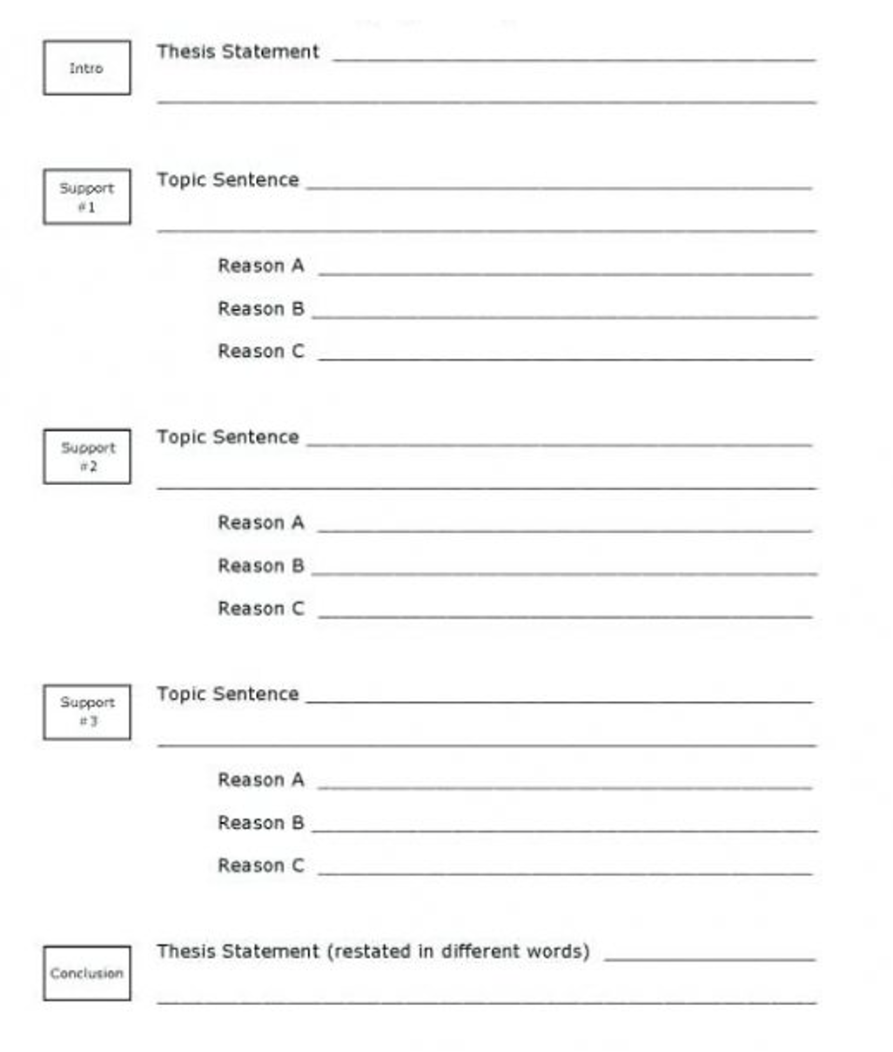
Criteria for Success: The grade is based on completing this essay template. If some of this worksheet is not completed, or there is room for improvement (e.g., if support points 2 and 3 are too similar), I will continue to work on it with you until it earns full points.

Sample Assignment #6: Peer Review for Writing Process

Purpose: First, this assignment ensures that you complete a full draft of the essay, which you will later revise for improvement. (Comments on the Essay Draft will come from me too, in a different context.) Second, the purpose of this assignment is to have you share your work and assist each other in the writing process. In addition to being an essential stage in the writing process, “workshopping” is an effective community-building exercise.

CLOs: 1, 3

First Essay Draft and Workshop

In this assignment, you will share your essay with someone else in class, and someone else will read your essay, to make sure you are fulfilling the first essay assignment. You will earn 10 points by posting a full draft; you will earn another 10 by reviewing another student’s essay.

The purpose of this activity is twofold: 1. Someone in the class double-checks to make sure you are completing the assignment correctly, and 2. You get to see how someone else has completed the assignment, possibly to generate more ideas for your own essay. You can also click around this discussion board to see other drafts, of course.

Upload a full draft of your essay. Not just a paragraph or a sketch, but a full, 2-3 page draft of your paper. Uploading a full draft of your essay is worth 10 points.

When you are ready to post your first draft, click "reply" below. Do not copy-and-paste your entire essay, but attach it as a file (I will show you how to do this on Canvas in class).

Once everyone has posted their essays, you then review the person's essay who posts above yours. (The person who posts at the very top will review the person at the bottom of the list.)

Your feedback to another student is worth another 10 points. Click "reply" to your classmate, and respond with two paragraphs:

1. Your first paragraph, which will consist of 5-7 sentences, will give some words of praise and encouragement. What is working well in the essay?

2. Your second paragraph, which will also consist of 5-7 sentences, will give some comments on how to improve the essay. Remember: every essay is a draft. What needs further development? If you cannot see anything "wrong" with this draft, you can always give suggestions as to how the essay could further develop.

Overall, you will give some general comments of praise and critique, but your primary concern is to make sure the essay has the following:
-MLA Format
-Introduction starts with an attention-getter
-Introduction ends with a three-part thesis
-Topics of body paragraphs correspond to three parts of thesis
-Paragraphs begin with topic sentences
-Everything in the paragraphs support topic sentences
-Conclusion begins with a restatement of the thesis
-Conclusion ends with another attention-getter
-Works Cited page is formatted correctly
...If any of these pieces are missing, let the author know!

Criteria for Success:

Your full draft (yes, including the Works Cited!) is uploaded to the DB. | /10
Your first DB paragraph discusses what is working well in your classmate’s essay | /5
Your second DB paragraph discusses what needs to be done, and/or how the essay could further develop | /5
Workshop total | /20

Sample Assignment #7: Exam Preparation

Purpose: This worksheet prepares you how to study for the upcoming exam in [the content course.] It instructs how to manage your time and effort for optimal exam preparation.

CLOs: 1, 4, 5

EXAM PREPARATION WORKSHEET

1. Exam Information
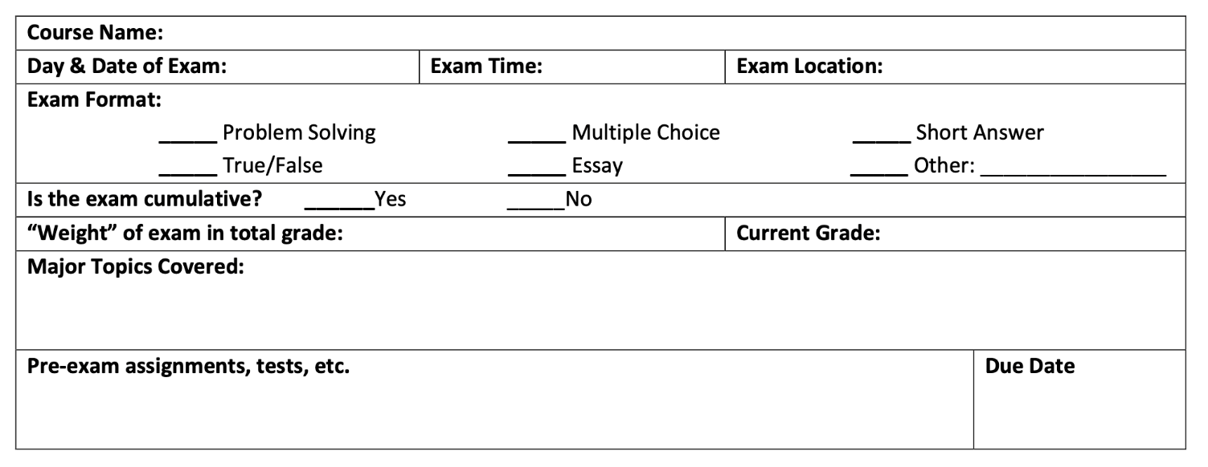 2. Organize Study Materials and Exam Preparation Activities: Review the checklist below to
identify all course-related materials that will be covered on your exam.

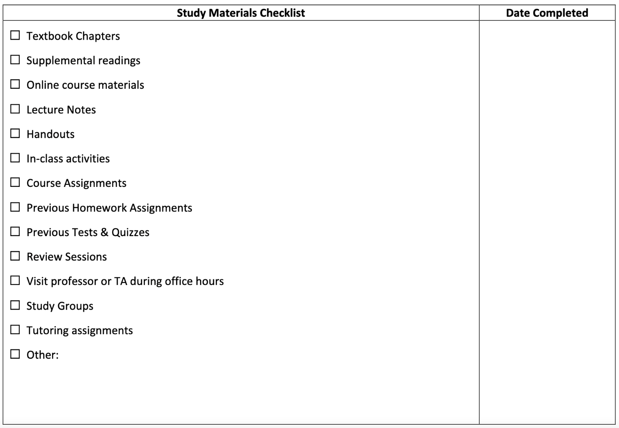
3. Study Completion Schedule: Develop a study schedule for your exam using the information from #2. Work backwards from Day 5 when developing your schedule, where day 5 is the day before your exam.

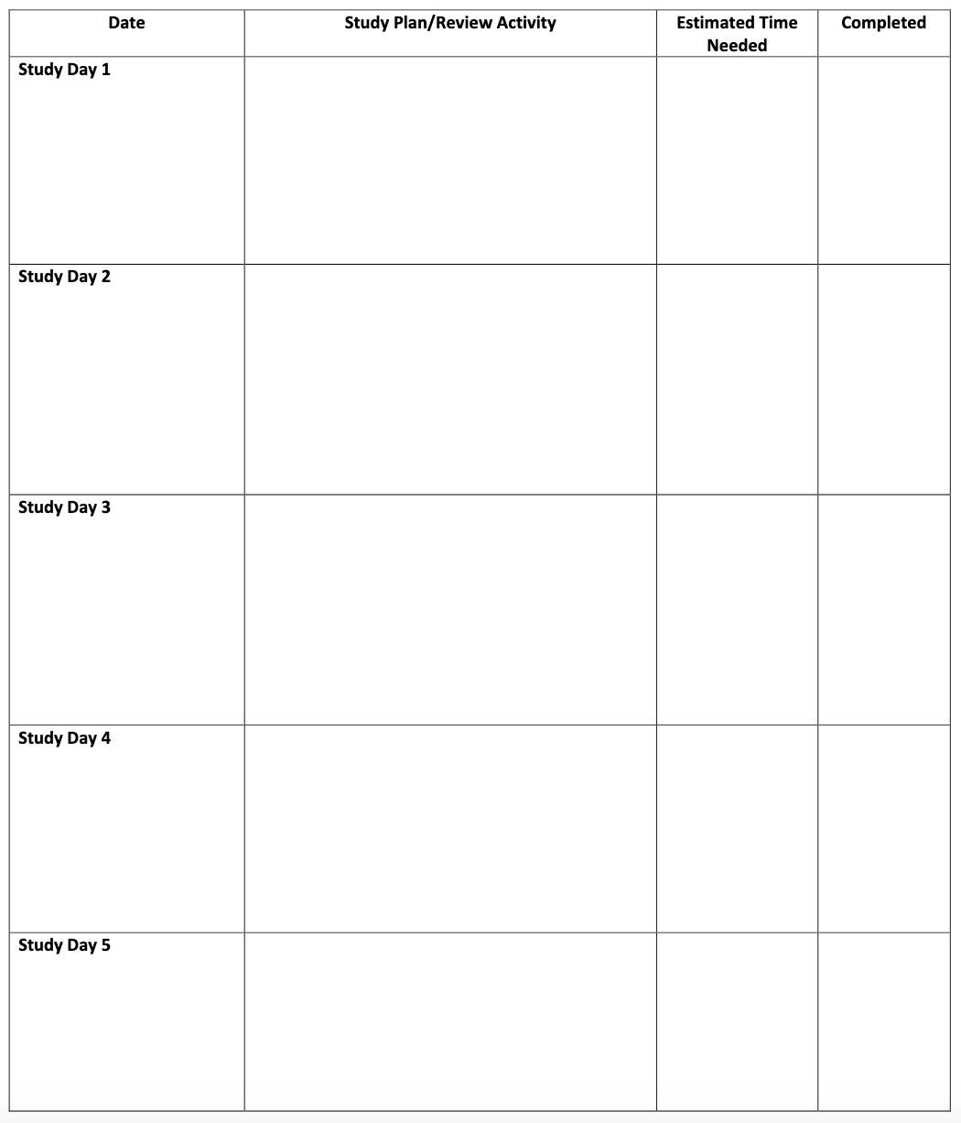

Criteria for success:

Part 1 is accurately completed | /10
Part 2 is accurately completed | /10
Part 3 is completed. Self-assigned tasks  are completed each day | /20
Total | /40

Sample Assignment #8: Self-Assessment

Purpose: A self-assessment serves two important purposes: 1. You develop meta-cognitive skills necessary for measuring areas of proficiency and growth, and 2. I get feedback, and further insight, into how you feel about your development as a writer.

CLO: 5

Diagnostic Essay reflection

Please answer the following questions about your diagnostic essay. Upload it as a word doc or a docx. You might want to answer some of these questions (or write about what feels most relevant to you):

-Do you feel that this essay accurately reflects you as a writer?

-What aspects of the writing process were most challenging?

-What was the most fulfilling part of the process?

-What do you feel are your strengths as a writer, as shown in this essay?

-What do you feel are your areas for growth, as shown in this essay?

-What did you learn from my comments (optional)?

Criteria for Success: This assignment earns points upon completion.

Sample Assignment #9: Vocabulary Quiz – Literary Terms
(CLO 2, CLO 4)

Directions: This week, we will be linking to the American Literature 1 (Links to an external site.) table of contents and then clicking through to "Literary Terms: A Guide" in the chapter, Reading and Interpreting Literary Texts. Review the literary terms guide and use it to answer the questions on literary terms in the Session 1 quiz, here on the Canvas course page.

This is a multiple choice quiz. You will find four possible answers for each question. You may take the quiz as many times as you like until you receive a grade that you are happy with.

Question 1 : 'The snake slowly, silently, slithered towards its prey' is an example of:
Possible Answers
- Onomatopoeia
- Alliteration (Correct Answer)
- Personification
- Symbolism

Question 2: The words, 'bang', 'whoosh' and 'bark' are examples of:
Possible Answers:
- Personification
- Alliteration
- Onomatopoeia (Correct Answer)
- Simile

Question 3: 'Her hair is like gold' and 'as strong as an ox' are examples of:
Possible Answers:
- Personification
- Symbolism
- Metaphor
- Simile (Correct Answer)

Question 4: A person in a story, or literary work.
Possible Answers:
- Character (Correct Answer)
- Protagonist
- Antagonist
- Plot

Question 5: The enemy, or bad guy of a story, or literary work.
Possible Answers:
- Character
- Protagonist
- Antagonist (Correct Answer)
- Plot

Question 6: Hints or clues about what will happen later in a story, or literary work.
Possible Answers:
- Plot
- Foreshadowing (Correct Answer)
- Theme
- Setting

Question 7: The time and a place of a story.
Possible Answers:
- Plot
- Protagonist
- Theme
- Setting (Correct Answer)

Question 8: The main character, or the hero of a story.
Possible Answers:
- Conflict
- Foreshadowing
- Protagonist (Correct Answer)
- Plot

Question 9: The problem in the story that needs to be solved.
Possible Answers:
- Conflict (Correct Answer)
- Plot
- Setting
- Theme

Question 10: The prediction of what will happen in a story, or literary work.
Possible Answers:
- Antagonist
- Plot
- Foreshadowing (Correct Answer)
- Conflict

Question 11: Irony is when an event or response occurs that is the ___________ of what is expected.
Possible Answers:
- exact outcome
- worst case scenario
- best case scenario
- opposite (Correct Answer)

