Community College of Philadelphia

Introduction to Health Care Professions
Allied Health 101

Fall 2020

Instructor:

Phone:

Office:

Email:
Course Information-AH 101-Introduction to Health Care Professions

Welcome to AH 101. This syllabus describes the course, its requirements, its policies and the course schedule. AH 101 was designed with your success in mind. Refer to the syllabus often
so that you can stay on track to reach your goals!

Course Description: This course introduces students to various aspects of the health care field. Students will explore a variety of health-related disciplines, create an academic and career plan for their chosen profession, and develop a health care e-portfolio. Students will study health implications for several cultural groups, including belief systems, communication styles and the role of the family. Professional behavior and essential qualities for health care professionals will also be addressed.

Placement: Open to all students at English Level II or higher placements.

Course Format: This course will be taught in an online format. Since you will not meet in a classroom, it is essential that you have reliable access to both computer and internet and that you check your course page daily. You will listen to lectures, respond to them, complete assignments and take exams online.

Office Hours: or by appointment

Student Learning Outcomes:

Upon successful completion of this course, students will be able to:

- Identify the essential qualities expected for health care professionals
- Describe the roles and responsibilities of individual members of the health care team
- Explain how to communicate effectively in respect to cultural, social and ethnic differences in the health care environment
- Demonstrate an understanding in performing medical math, taking vital signs, maintaining infection control standards and using medical terminology
- Develop an academic plan and success portfolio

Core Competencies:

The courses required for your degree program, including general education requirements, help you develop core competencies. AH 101 is a required course in the Health Care Studies Program curriculum. From the required assignments and activities in this class, you will begin the development of these core competencies:

- Effective Communication
- Critical Thinking
- Quantitative Reasoning
- Scientific Reasoning
- Information Literacy
- Technological Competency
- Responsible Citizenship

Grading:

AH 101 is designed with many opportunities to earn strong grades.

Evaluation will be based on the following:

- Exams (25 %)
- Success Plans (30 %)
- Lecture Responses (10 %)
- Learning Labs (10 %)
- Chapter Homework (10 %)
- Building Med Term & Med Math Quizzes (5 %)
- Culture & Health Care Project (10 %)

The grading scale for the course is as follows:
90-100% A
80-89% B
70-79% C
60-69% D*
< 59 % F*

*A grade of C or better is required for the Health Care Studies curriculum. Students earning a D or F will need to repeat the course.

Integrated Student Supports:

College is challenging, and you will need to work hard to reach your goals. To help you succeed, student supports are built into AH 101. Be sure to use them by reaching out for help when you need it.

An academic advisor and counselor are assigned to each section of AH 101. They will present via recorded messages and review some of your assignments. They might leave comments for you to consider. You can reach out to them at any time through the Canvas course. Other student supports for AH 101 include Single Stop staff, Learning Lab specialists and librarians. Individualized support may be provided through any of the student support offices at https://myccp.online/how-access-virtual-student-support-services . I can assist you in connecting with the support you need.

Required Textbook:

When you register for the course, a course fee covers MindTap access including the e-textbook. MindTap is required and essential to the course to complete assignments and prepare for exams. A low-cost textbook will be available in the College Bookstore if you would prefer not to read the text online.

Introduction to Health Care, by Doreen Dakota Mitchell and Shirley, Lee Haroun, 5th edition.

Course registration gives you access to the online textbook and MindTap. MindTap is designed to help you master the material covered. Interactive videos, animations and activities create a learning path to guide you through the course and focus on what’s important. Links to required MindTap activities are found in the course modules in Canvas.
Use of Technology:

As a student and a future health care professional, you will be required to use many different computer programs and applications. AH 101 gives you the opportunity to become more comfortable and competent with the use of technology. If you need assistance, don’t hesitate to ask for help!

You cannot complete assignments using mobile devices. You must use a computer to be able to submit the assignments and receive credit for them.

Please note that technology issues are not an excuse for late work. It is your responsibility to begin work early enough so that if technology issues occur, you can contact technology support at Canvas or Cengage and submit work before the deadline.

Prepare to Achieve Your Goals:

Begin the semester by completing the Prepare to Achieve Your Goals! assignment. Students face many hurdles, but Community College of Philadelphia has resources to help you succeed. After reading through the information, be sure to respond in the textbox to receive credit for this assignment!

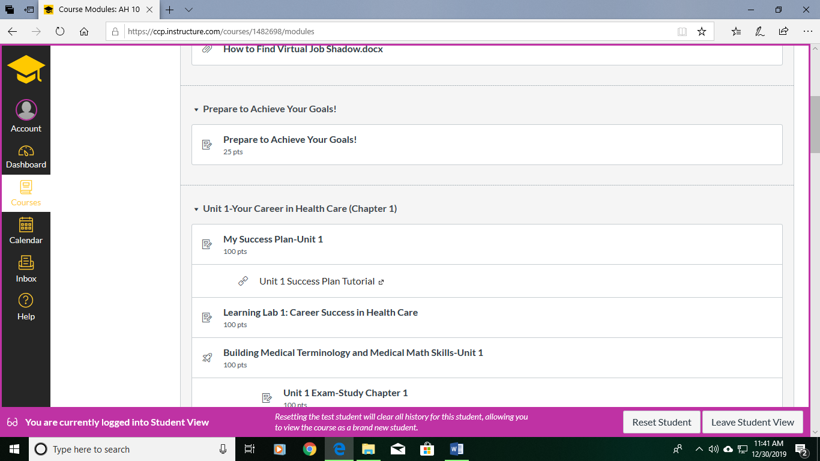

Success Plans:

AH 101 is designed to help you reach your goals. During the semester, you will create a series of success plans. The plans use a tool provided by the College: Virtual Job Shadow. Each plan involves work in Virtual Job Shadow followed by a document download. These downloads and a reflection paragraph are submitted through the Canvas assignment page. Complete instructions can be found by clicking into the Success Plan. A video tutorial is also posted on Canvas beneath the Success Plan link.

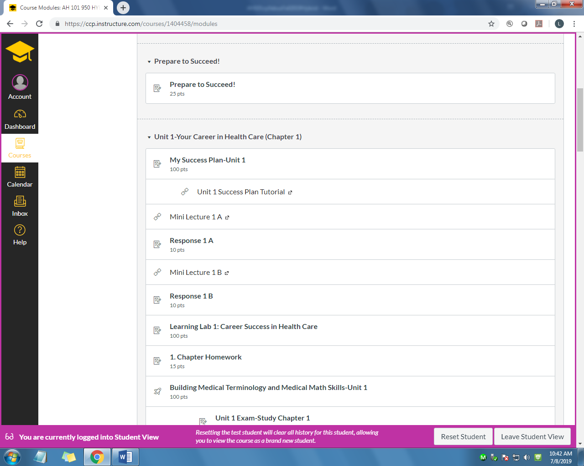

Success plans WILL NOT be accepted in paper form (hard copies) or as attachments to Canvas e-mails. They must be submitted through the Canvas assignment page so that your grade can be processed into the grade book.

If you do not earn at least a 70% on the success plan by the due date or do not complete the success plan, you will be given a one-week extension from the success plan’s original due date. A 30 % deduction will be applied to late work. Due to scheduling constraints, a due date extension will not be available for Unit 5.

Health career programs are competitive, admitting the strongest of student applicants. Being successful involves understanding how to learn, choosing an appropriate academic and professional goal, making a realistic plan to reach goals and proactively preparing for the chosen career.
Mini Lectures and Responses

In this hybrid course, you will listen to lectures and respond to the information online. Lecture material is broken into short chunks of information and presented by video. After each Mini Lecture, there is a required response which must be completed in order to earn points counting toward your course grade.

If your response is adequate in answering the questions asked, you will receive the points for that assignment. If not, you will receive 0 points. A one sentence answer or vague response is not adequate. These response assignments cannot be resubmitted and cannot be submitted after the due date.

The health care content of this course is vital to prepare you for health care program application and health care program success. Lecture material covers that content along with textbook reading. It is important that you commit to mastering course material.

Learning Labs:

You will complete Learning Labs for each unit of study. The Learning Labs are interactive computer-based lessons that automatically generate a grade. You will find the Learning Labs in the course module. Simply click on the link to begin.

You can take the Learning Labs twice and your highest grade will be recorded. Extensions to the deadline are not available. Links to the Learning Labs are found in the Canvas course modules.

Health care students must be able to learn independently using different forms of instruction. Online learning has become fundamental to health care education. It is important that students increase comfort level with work done independently in an online environment.

Chapter Homework

Each unit of this course requires that you read two chapters from your textbook, except unit 1 which requires only one. For each chapter read, you will complete a Chapter Homework assignment which is an online quiz covering the material.

You can take the Chapter Homework assignments twice and your highest grade will be recorded. Extensions to the deadline are not available. Links to the Chapter Homework assignments are found in the Canvas course modules.

To succeed in college, you must master the reading and comprehension of textbook material. Unit exams are based on content covered in class, online lectures and the textbook. Students who do not read the textbook perform poorly on exams.

Building Medical Terminology and Medical Math Skills:

Becoming stronger in any skill requires practice! To build skills in medical terminology and medical math, you will take an online quiz in Canvas during each unit. Building these skills is important for success in health care programs.

Refer to chapters 4 and 5 as you complete the quizzes. For a review of math topics covered, follow the links embedded in the quiz description. You are also encouraged to work with a math tutor in the Math and Business Learning Lab if needed. To schedule an appointment with a math tutor, visit B2-26 or ask your instructor to submit a Starfish referral.

You are allowed two attempts for each quiz and the highest grade will be recorded in the gradebook. There is no time limit for taking the quiz but once the deadline has passed, you will receive a 0 for a quiz that is not submitted.

If you submit the quiz by the deadline, you may earn back half of missed points on the math section by meeting with the math tutor in the College Learning Lab to review the quiz. If you are interested in meeting with a math tutor, you should ask your instructor to post a referral through Starfish

Health care programs require students to use medical terminology and perform basic arithmetic with accuracy. Misinterpretation of medical language or mathematics errors can cause great harm to patients. With commitment to practice, you can become competent in these essential skills.
Unit Examinations:

To be successful, you’ll need to learn how to prepare for exams and take them with skill. Once again, this takes practice! If you would like more guidance in study techniques and test taking skills, be sure to ask about being connected to a Learning Lab specialist.

You will take five exams during the course. All exams will include a minimum of 50 questions.
You will take the exams online during a specified 24-hour period and will be given 50 minutes to complete the exam.

Please notify me before the exam if you will not be able to take the exam during the scheduled 24-hour period. You will also need to schedule a make-up exam. You will need to show documentation which verifies that your inability to take the exam was unavoidable. If you cannot show documentation, a 30 % deduction will be applied to your exam grade.

Health care students are required to master challenging course material. Student assessments often take the form of examinations. Additionally, students must take comprehensive and difficult examinations to become credentialed in most health care professions. Learning how to prepare for and successfully complete examinations will enhance student success.

Culture and Health Care Project:

College and Departmental Policies

Department of Allied Health
Student and Faculty Responsibility Statements

An effective faculty-student partnership is an essential component to achieving student academic success. As is true in any partnership, both parties are expected to contribute. Faculty members bring knowledge and expertise to the partnership. Their responsibility is to create an environment conducive to learning and to promote opportunities for student learning, all the while respecting the diversity of the student body. Faculty members have a professional responsibility to plan and deliver quality instruction as defined by course objectives and to clearly outline expectations. This includes, but is not limited to:
- Evaluating student work in a fair, objective and timely manner;
- Respecting opinions without demeaning the student;
- Giving help and clarification when needed;
- Being accessible and approachable to students (e.g. maintaining posted office hours and arranged appointments)
- Having a positive, caring attitude toward teaching and learning; and
- Presenting facts and skills in an organized manner that respects various learning styles.

Students contribute effort and potential to the partnership. Students are responsible for participating in the learning process in a conscientious manner while taking full advantage of the educational opportunities available. Students are also expected to conduct themselves in such a manner as not to interfere with the learning of others. The following list is not meant to be inclusive, but rather further defines the student’s role:
- Come to all class sessions prepared and on time;
- Display interest in the subject matter through participation, questions, etc.
- Bring forth concerns to appropriate individuals;
- Seek help and clarification when necessary (e.g. through tutoring, study groups, questions)
- Engage in accurate, objective self-assessment of own work and continually be aware of class standing/performance;
- Understand the instructor’s expectations and methods of assessment; and
- Initiate all paperwork necessary to enroll in and exit from the course, including financial aid documents.

Everyone has a responsibility to respect the rights of others with regard to academic affairs. This includes:
- Refraining from inappropriate comments;
- Engaging in objective discussions when differences occur;
- Developing sensitivity to diversity among students and faculty;
- Allowing others an equal chance to participate; and
- Respecting the personal time of others

The welfare and academic success of the students are the primary considerations for the learning partnership. The contributions made by both faculty and students are critical to the success of the partnership.

Academic Honesty Standards:

A foundation of mutual trust and individual responsibility is essential in an academic community. Faculty at the Community College of Philadelphia try to create an environment in which honesty is encouraged and dishonesty discouraged. Students are obligated to demonstrate respect for the principles of academic integrity by not participating in acts of academic dishonesty and by reporting violations to faculty or administration. (Please also refer to the College Student Handbook)
Academic dishonesty may take many forms. The following list may not be inclusive:

Cheating: using unauthorized assistance, materials, or study aids in an academic exercise
Plagiarism: using the words or ideas of another without appropriate acknowledgment
Fabrication: falsifying or inventing information or data
Deception: misrepresenting work or academic records; forging signatures
Electronic Dishonesty: using network access in an inappropriate way, having an impact on a class or the work of others
Facilitating Academic Dishonesty: intentionally assisting another student to commit an act of academic misconduct
Students who commit acts of academic dishonesty will be subject to disciplinary action by the College through due process procedures for student conduct violations. The penalties, listed in order of increasing severity, may be:

- re-doing the project;
- lowering the project grade;
- no credit for the assignment;
- lowering the course grade;
- failure for the course;
- removal from the academic program;
- dismissal from the College.

The term “project” is not limited to classroom assignments and includes examinations, library assignments, and any other exercises faculty evaluate.

A student suspected of cheating during an examination will receive a grade of “zero” for the exam with no ability to take a retest.

Withdrawal Policy:

The last date to withdraw from your courses is June 15, 2020. Though you won’t earn an F if you withdraw, before you decide to withdraw from this course or any other course, think about the following information:
a. The W will be reflected on your transcript permanently.
b. W’s on transcripts may have a negative impact on acceptance into select programs.
c. Transfer institutions may view W’s negatively, and it may go against your application.
d. Your financial aid may be impacted.

Please discuss your options with your instructor or an advisor/counselor before you decide to withdraw from a course. Since AH 101 is a required course in the Health Care Studies Program, if you withdraw from the course, you will need to repeat it next semester.

Other Important Information

Starfish Connect:

Starfish Connect is a communication tool for students and faculty. Through Starfish, instructors can provide feedback to you about course progress. Throughout the term, you may receive progress emails regarding your academic performance. The emails are designed to be helpful and increase your success in courses. Be sure to open any emails you receive and follow the recommendations. Instructors may also recommend that you contact a specific campus resource, such as the Learning Lab or Counseling Center. If an instructor makes a referral, you may also be contacted directly by this campus service as a follow-up. To access Starfish Connect, simply log into Canvas and click on the link titled "Starfish Connect." You can even set up a student profile. If you need assistance with Starfish Connect, you can email questions to: starfishconnect@ccp.edu

Center on Disability:

Reasonable accommodations and academic adjustments are coordinated with all qualified students with disabilities on an individual basis through the College’s Center on Disability. In order to receive special accommodations, students are required to submit comprehensive documentation from a qualified professional stating the nature of their disability and attend a meeting at the Main Campus with the Center’s counselor to discuss and review appropriate academic adjustments.

To ensure timely and effective service provisions, students requiring special accommodations are urged to apply to the College no later than one month before the start of the semester.

In order to receive special testing and/or classroom accommodations, students with disabilities must be registered with the Center on Disability and must provide the accommodation forms to the instructor as soon as possible.

Course Schedule:

Work is clearly outlined in the modules of the Canvas course. Each assignment must be completed by the due date. Success Plans are the only assignment which will be accepted within one week past the due date but they will be graded with a 30 % deduction.

Unit | Textbook Chapters | Start Date | End Date/Work Due
1 | 1 | September 8th | September 20th
2 | 12 & 13 | September 21st | October 11th
3 | 15 & 16 | October 12th | November 1st
4 | 4 & 5 | November 2nd | November 22nd
5 | 10 & 20 | November 23rd | December 12th
6 | Culture & Health Care Presentation |  | Assigned Finals Period

